Digital Logic Lab 7 Report

Digital Logic 2116L

3/19/2018

Featheringill 210

Suyi Diao, Bryce

1. Introduction:

The basic concepts we learned for this lab how to flip flops to build a circuit that could get results when the button is pushed instead of directly get the result,.

1. Design Requirements:

We need to build the circuit from part 2 of the lab into the mother board, a four bit adder that only shows the result when a button is pushed.

1. Diagrams

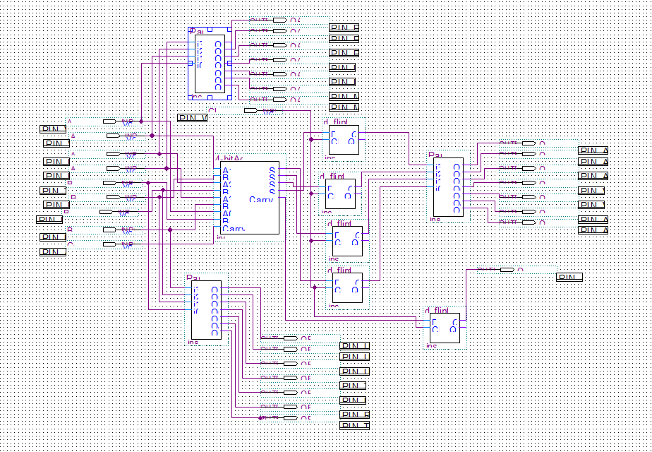

1. Results

The lab runs smoothly and correctly on the motherboard.

1. Discussion

Everything in the lab runs smoothly, we did the prelab and the implementation process to the board took a lot of time

1. Conclusion

I learned how to use flip flops to build a delayed result circuit.

1. Post-Lab Questions

